**Smart Investment Planner Using Machine Learning**

*Dr.M.Kiran Kumar1, Abhinav Unnamatla2, Jasti Amit3, Medhansh Kotipalli4*

*1, 2, 3, 4Department of Data Science, GRIET, Hyderabad, Telangana, India.*

**Abstract**

Since the stock market is highly unpredictable, offers little individualization and doesn’t always fit personal needs, investing there can be difficult. The flexibility and level of detail expected by today’s investors are usually not achieved by traditional market analysis. To address these shortcomings, this project introduces an AI based forecast and recommendation system for the Bombay Stock Exchange (BSE) that concentrates on the top 50 companies listed there. Inspired by these companies, the system is developed in PyTorch and includes a convenient web interface designed using Streamlit. It relies on a Temporal Convolutional Network (TCN), chosen for its talent at spotting important trends and patterns across long periods in time-series data. Historical stock prices are improved through a new preprocessing process that uses both moving average and Hilbert Transform. To avoid unclear forecasts, a mechanism is built into the model that averages out sudden market spikes. To avoid unreliable outcomes, the technique restricts price changes day by day to no more than 2%. In addition to forecasting, it updates data in real time, lets users check model success rate and sorts stocks according to individual interest. The project is designed to adjust its results to users’ level of risk, their approach to investing and their budget, giving them relevant information to guide their actions. It tries to increase confidence and ability to make smart choices as the stock market changes.

**Keywords:** Temporal Convolutional Network(TCN), Hilbert-Huang-Transform (HHT), Signal Decomposition, Moving Average Smoothing.

**Introduction**

In the modern fast-paced financial setting, the stock market plays an important role in accumulating wealth, in making long-term investments, and in the growth of the economy. Picking the right stocks from hundreds of choices may seem daunting to everyday investors, though, when they’re not backed by years of knowledge and countless hours spent studying trends. We’ve created a proprietary knowledge-based stock recommendation system relevant exclusively for companies listed at the Bombay Stock Exchange (BSE). By leveraging the power of artificial intelligence and deep learning, our system inspects the previous performance of stocks and provides smart data-driven prediction on future stock prices.

A core of the system is a strong deep learning model, a Temporal Convolutional Network (TCN). Unlike old techniques such as RNNs or LSTMs, TCNs are more efficient and accurate in processing time-series data – due to their capability to process sequences in parallel and remember patterns through a long period. To take it up another level we’ve included a custom signal decomposition step utilizing moving averages and the Hilbert Transform. This aids in the simplification of complex stock signals into less complex components to increase the accuracy of our forecasts. We’ve also ensured that the system is easy and natural to use. Based on Streamlit technology, the app allows users to work with a clear, friendly interface. Investors can define their preference; risk level, investment duration, budget, etc. and the system will do all the heavy lifting. It uses a custom scoring method to evaluate predicted returns and ranks the best 5 stocks of BSE which suit the user’s profile best.

By combining smart algorithms, deep financial insight, and smooth user experience, this project seeks to help both novice and seasoned investors with a powerful asset they can rely on to make educated investment decisions – without becoming a stock market genius.

**Literature Survey**

**[**1] Qin et al. proposed using a two-way attention-based RNN to make time series prediction more accurate by combining input attention and temporal attention. We wanted to focus on improving the understanding and precision of forecasts from models built on multivariate time series. It was important for their architecture to pick different learning periods on demand so that the model only paid attention to key data. Since this work uses RNNs, the addition of attention fits naturally with TCNs and provides another approach toward adding explainability to temporal models.

[2] Bai et al. carried out research comparing how convolutional and recurrent models perform in sequence modelling, considering accuracy, the memory used and how easily they can be run in parallel. They tried to see if Temporal Convolutional Networks (TCNs) performed well when compared to LSTM and GRU. Benchmarking revealed that TCNs excel over many other models when it comes to both long-range learning, consistent gradients and the time needed to train. Based on the findings, TCNs can be used for forecasting in areas where both speed and modelling for stable future trends are important, including stock forecasting.

[3] Akansu and Haddad Put together a major source of information on multiresolution methods, for instance, wavelets and subband transforms. Researchers were provided with ways to study signals from multiple frequency bands. Their time-frequency localization rules and structured decomposition allow for processing steps in financial forecasting, so trends and noise can be identified from stock time series. These techniques greatly influence how signal decomposition pipelines are structured, especially those that involve custom Hilbert Transform methods in current forecast systems.

[4] Boashash the author proposed a method for measuring instantaneous frequency (IF) based on the Hilbert Transform, aimed at the study of non-stationary signals. The goal was to separate out local frequency parts to improve understanding of the signal. The approach is important for financial time series where there are frequent changes and fluctuations. This study demonstrates how using IF features can help describe the ups and downs of stocks for use in forecasting and spotting inconsistencies.

[5] Zhang and Wu created a new forecasting model that joins Bees Colony Optimization (BCO) with deep learning for predicting the S&P 500 stocks. The chief goal was to apply BCO for selecting features and adjusting hyperparameters, allowing deep learning to identify hard-to-see temporal patterns. When using their method, predictions were more accurate in markets with a lot of ups and downs. Blending optimization and learning allows advanced preparatory stages and model changes, making it important for systems that mix signal decomposition and TCNs in finance.

[6] Hornik et al. theory confirms that multilayer feedforward neural networks are able to approximate any function. The purpose of the work was to build the mathematical basis of what neural networks can do. The outcome demonstrates that deep learning models such as TCNs can be used for forecasting because they handle the nonlinear changes in markets. The work supports the decision to use neural networks for data-driven tasks in financial prediction.

[7] Patel et al. Investigated standard machine learning techniques such as regression and decision trees, to explore stock market trend prediction. The purpose was to check the algorithms and determine their strengths and weaknesses in performance. Even though they are not as advanced as neural models, both research results demonstrate the significance of preprocessing your data, as well as the right model selection. The research helps us understand why deep learning solutions like TCNs are useful in the noisy world of finance.

[8] Broomhead and Lowe RBF networks for multidimensional function interpolation and learning were presented. The aim was to give a flexible method for approximating functions when working with time series. Although they do not deal with TCNs, the structure principles from adaptive networks affect today’s neural networks. The findings can help include RBF-based parts in hybrid systems for forecasting financial time series.

[9] Hassani and Zhao considered how the Hilbert-Huang Transform (HHT) can be applied in practical situations to analyse non-linear and non-stationary signals using a spectrum analysis. They wanted to highlight the effectiveness of HHT, along with both EMD (empirical mode decomposition) and instantaneous frequency estimation, in applied cases. As a result, this research recommends using frequency-based decomposition when forecasting stocks and offers directions for updates in Hilbert-based preprocessing routines.

[10] Jain and Sharma applied various machine learning tools such as decision trees and neural networks, were applied to stock price forecasting. They drew attention to the fact that neural approaches are outstanding in handling challenging financial cases. Our target was to find methods that would be both accurate and suitable for operation in practice. The outcomes back up TCN models and show that successful use of these models requires careful feature engineering and effective data preprocessing.

[11] Devlin et al. examined the use of Temporal Convolutional Networks (TCNs) as a method for stock forecasting and compared how well they work compared to LSTM networks. The study revealed that TCNs manage well to remember series of events and are able to detect dependencies in data, regardless of their length. Since causal and dilated convolutions are present in their model, this work justifies our selection of TCNs for financial applications.

[12] Srivastava and Kumar compared Long Short-Term Memory (LSTM) and Gated Recurrent Unit (GRU) models for the task of stock forecasting. They were investigating how much prediction accuracy was affected by improvements in efficiency. It was discovered that GRUs run more quickly, but on some occasions they are not as accurate as LSTMs. These observations are valuable, regardless of their structure and may prove useful in pairing TCNs and recurrent networks in upcoming upgrades.

[13] Rumelhart, Hinton, and Williams introduced of the backpropagation algorithm, learning in deep neural networks was made much easier. Enabling gradient flow across many layers made it possible for us to design and train complex models such as Temporal Convolutional Networks (TCNs). Thanks to this algorithm, many modern forecasting systems are able to pick out valuable information from financial data and predict results accurately.

[14] Pardeshi et al. has introduced a hybrid LSTM model: one that uses a Sequential Self-Attention Mechanism (SSAM) to predict Indian bank stock prices. We wanted to make forecasting more accurate by having the model pay attention to important points in time. Traditional methods were outperformed by the new tests in terms of RMSE and R². The findings of this research encourage adding attention mechanisms to time series models for forecasting and help advance efforts to improve financial systems.

Table 1 summarizes the objectives, methodology adopted, advantages along with their drawbacks of the existing approaches in detail.

**Table 1:** Summary and existing approaches.

|  |  |  |  |  |  |
| --- | --- | --- | --- | --- | --- |
| **Reference No.** | **Authors** | **Objective** | **Methodology** | **Advantages** | **Drawbacks** |
|  | Qin et al., 2017 | Improve time series forecasting via attention mechanisms | Dual-Stage Attention RNN with input and temporal attention | Enhances interpretability and focuses on informative time steps | RNNs are sequential and less efficient for long time series than TCNs |
|  | Bai et al., 2018 | Compare CNNs, RNNs, and TCNs for sequence modeling | Empirical benchmarks on various sequence tasks | Proves TCNs outperform RNNs in accuracy and speed | Limited financial domain applications tested directly |
|  | Akansu & Haddad, 2001 | Theoretical foundation for multiresolution decomposition | Uses wavelet and subband transforms | Enables signal denoising and trend extraction | Theoretical; lacks practical financial forecasting applications |
|  | Boashash, 1992 | Define and estimate instantaneous frequency (IF) | Hilbert Transform and IF estimation in non-stationary signals | Facilitates frequency-based feature extraction | Complex to implement and interpret in real-time systems |
|  | Zhang & Wu, 2019 | Combine optimization with deep learning for forecasting | BCO + deep learning for S&P 500 prediction | Improves accuracy in volatile markets | Computational overhead from BCO optimization |
|  | Hornik et al., 1989 | Prove universality of multilayer networks | Theoretical function approximation proof | Justifies deep learning in forecasting | No implementation details or financial context provided |
|  | Patel et al., 2015 | Compare ML algorithms for stock trend prediction | Tested classical models like regression, decision trees | Useful for benchmarking and preprocessing insights | Lacks deep learning or modern methods for better performance |
|  | Broomhead & Lowe, 1988 | Introduce adaptive networks for function interpolation | Developed radial basis function networks | Influenced neural network designs | Outdated model not competitive with modern architectures |
|  | Hassani & Zhao, 2010 | Review HHT and its applications in signal analysis | Described EMD, IF, and Hilbert-based tools | Validates frequency-based decomposition | EMD can be unstable and hard to implement efficiently |
|  | Jain & Sharma, 2021 | Explore ML for stock price forecasting | Tested traditional models on Indian stocks | Confirms superiority of deep learning | Limited to small datasets and lacks temporal modeling depth |
|  | Devlin et al., 2020 | Assess TCNs for financial time series | Used dilated convolutions and causal padding | TCNs outperform RNNs and LSTMs in some cases | Lacks hybrid model exploration with attention or decomposition |
|  | Srivastava & Kumar, 2020 | Compare GRU and LSTM models | Experimental performance comparison on stock data | GRUs are efficient; LSTMs better at longer dependencies | Both models lack parallelism and are slower than TCNs |
|  | Rumelhart et al., 1986 | Introduce backpropagation for learning | Gradient-based weight updates in deep networks | Core to training modern neural networks | Susceptible to vanishing gradients in deep RNNs |
|  | Pardeshi et al., 2023 | Use LSTM with self-attention for stock prediction | LSTM + Sequential Self-Attention on Indian banking data | Improves RMSE and interpretability | Higher model complexity and training time |

**Proposed Method**

**Problem Statement**

Today, making predictions about stock prices is tough because the markets are full of complex, surprising and wide data. Frequently, ARIMA and SARIMA models do not catch sudden nonlinear movements in markets, so their results do not provide useful guidance for both instant and future choices. Because not many user-friendly systems connect advanced forecasting to good decision-making, many people are unable to access modern financial tools. The main aim of this project is to remedy the gap by offering a simple, fun and effective stock forecasting and suggestion platform using improved TCN and advances such as Hilbert Transform and Moving Averages. The purpose is to assist all our users by providing interpretable information that aids in setting up successful ways to invest money.

**Objectives**

* Timely and accurate market data is delivered by the system as it connects with real-time prices, trade volumes and indices using strong APIs. With data streaming, decisions about investments can be made quickly and regularly.
* By using Hilbert–Huang Transform, we generate the Intrinsic Mode Functions in the stock data.,as it gives significant clarity to spot more visible trends in the market.
* Dilated causal convolutions give TCNs the ability to detect different trends in the data, both quickly and continually. Essentially, the data provided by the IMF now allows us to forecast stock prices for several days in advance.
* Depending on what the prices dropped to, the user’s preferred level of risk and how fluctuating the markets are, stocks end up in one of three risk categories. It brings together portfolios that have an expected return that fits well with users’ risk preferences.

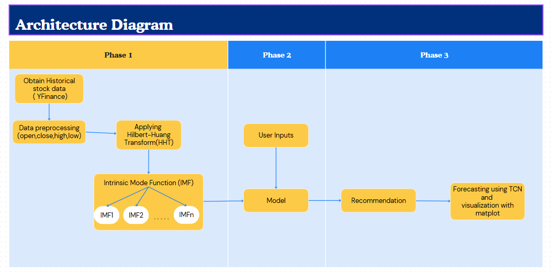**Architecture Diagram**

**Figure 1:** Architecture Diagram

**Modules in the proposed work:**

**Phase I - Generating IMF’s:**

In Phase I, the YFinance library provides precise information on historical open, close, high and low prices for different companies and stocks. Once we’ve collected the information, we take care of getting rid of unwanted records, match tables and make them ready for more exploration. After preprocessing, the Hilbert-Huang Transform (HHT) is used to analyze time series data that is not straightforward or consistent in its patterns. The approach isolates different Intrinsic Mode Functions (IMFs) that show how various stock price movements are represented by various frequencies. Just the IMFs that are relevant are included in the training, so that actionable signals are only used for producing predictions.

**Phase II - Training the model**

In Phase II, data like the individual’s aims for making investments, risk views, timing expectations and companies are collected into the system. This data is used by the platform to offer users different investment recommendations. The system makes use of the extracted IMFs to instruct a Time Convolutional Network to detect patterns in long series without running into vanishing gradient challenges. With both these signals and the user’s choices, the model tries to predict the future direction of the stock price. When predictions are ready, the system reviews the stocks and delivers unique advice that works well with each customer’s goals and risk tolerance.

**Phase III - Forecasting with TCN**

In Phase III, the TCN model is applied to predict future prices or returns after using the corrected data. With the predictions done, Matplotlib uses charts to show a review of past data together with what to expect in the future. Because visuals are used to explain the information, the system makes it clearer for users what the future trends are likely to be. Collecting, cleaning, interpreting, training on and making recommendations using data all help investors make the best choices.

**Experimental Results**

**Input**

Thorough testing was completed on the proposed Smart Investment Planner to ensure that the integrated system was accurate, built to last and useful in practice. The system is designed to personalize results based on each user’s goals, handling risk, available budget and their preferred companies. Thanks to these inputs, the system can design its stock list and forecasts to match the client’s needs, making investment advice more helpful.

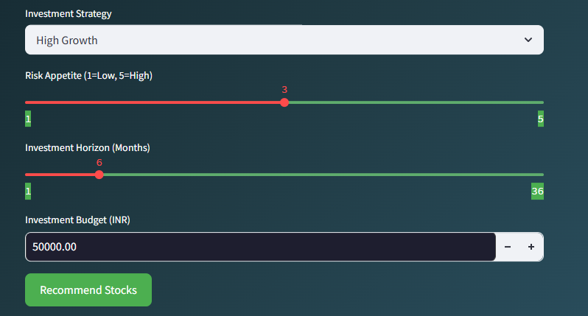 **Figure 2:** Sample input.

Figure 2 illustrates the input interface, where users can specify:

**Right Investment Strategy**

When it comes to investing, picking a strategy that fits your personal goals and mindset is crucial. If you're aiming for maximum growth and are comfortable taking on more risk, a High Growth strategy might suit you—this focuses on stocks with the highest projected returns. On the other hand, if you prefer something more predictable, a Stable Returns strategy targets companies that grow steadily over time. If you're someone who wants a bit of both, a Balanced approach offers a healthy mix of growth and consistency, helping you spread your risk while still aiming for decent returns.

**Short-Term vs Long-Term Focus**

How quickly you want to see returns also plays a big role in choosing an investment strategy. Short-Term Gains strategies are designed for quick results—investing in stocks or assets that may grow in a matter of weeks or months. This approach can be rewarding but often comes with higher risk and requires more active involvement. In contrast, Long-Term Investment strategies are built around patience. They focus on steady, reliable growth over several years and are ideal for people looking to build wealth gradually without the need for frequent portfolio changes.

### **Understanding Investment Duration**

Your investment duration—whether short, medium, or long-term—can greatly influence the kinds of assets you choose. Short-term investors often look for lower-risk, high-liquidity options, while long-term investors have more flexibility to ride out market fluctuations and invest in assets with greater growth potential. Aligning your duration with your financial goals ensures your investments are working for you in the right time frame.

### **Risk Tolerance and Budget Considerations**

Two other key factors to consider are your risk tolerance and your budget. Everyone has a different comfort level when it comes to taking risks. Some investors are fine with market volatility, while others prefer more stable options. Knowing your risk appetite helps avoid stress and bad decisions down the line. Your budget—how much capital you’re willing and able to invest—also shapes your strategy. Whether you’re starting small or investing a larger amount, setting a clear budget ensures you stay within your means while working toward your financial goals.

Upon processing these inputs, the system produces:

Based on user needs and what’s happening in the market, we recommend the following top 5 companies (Figure 3).

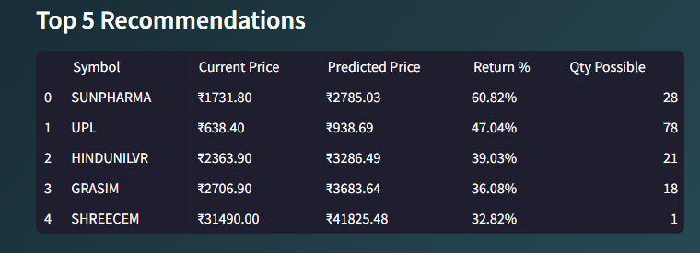A visual representation (Figure 4) that allows users to see both past and estimated prices for any chosen company, examining their volatility over different periods.

**Figure 3: Top 5 Recommended Companies**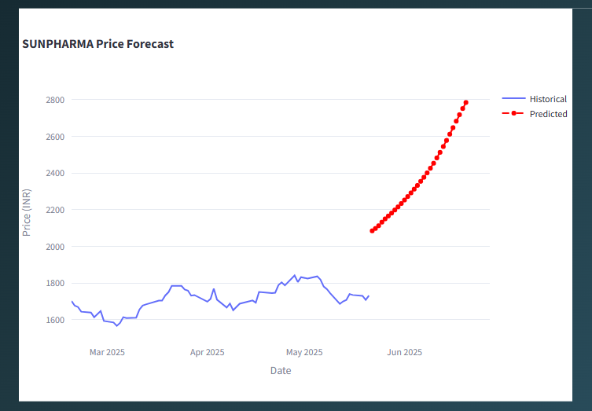

**Figure 4: The interactive chart of the selected company**

The interactive chart adds zooming features, tooltips and automatic updates to help users recognize worldwide patterns, assess how reliable the forecasts are and make decisions quickly.

Model Evaluation and Performance Comparison

The main model used in the system is a Temporal Convolutional Network (TCN) because it is designed for spotting temporal structures in data that changes over time. When compared to standard recurrent networks, TCNs can learn from both short- and long-term sequences more reliably, thanks to dilated causal convolutions.

Raw stock price time series data were improved for modeling by processing them with the Hilbert-Huang Transform (HHT). By doing this, it separates the data into different oscillatory modes, each captured by an Intrinsic Mode Function (IMF). The decomposition process accomplishes two major functions.

**Noise Reduction:** Excluding the high-frequency signals that don’t benefit the model, the data becomes simpler and easier for the model to use..

**Feature Enrichment:** By filtering through IMFs, the TCN can understand more closely the different characteristics that are hard to see in original market data.

Data for testing comes from the Bombay Stock Exchange (BSE) and represents all sorts of market situations over many years such as positively sloping, negatively sloping and highly fluctuating ones.

**Evaluation Metrics:**

To quantify the predictive quality, three metrics were used:

**Accuracy (%):** The amount by which the predicted price at the end of the day differs from the actual value which is compared by setting a cutoff level.

**Root Mean Squared Error (RMSE):** It is a quadratic way to measure how well the model predicts, powerfully punishing major errors.

**Mean Absolute Error (MAE):** Gives an average value for errors, making it easy to understand how forecasts can be trusted.

| Model | Accuracy (%) | RMSE | MAE |
| --- | --- | --- | --- |
| TCN | 92 | 1.5 | 1.2 |
| ARIMA | 78 | 3.2 | 2.8 |
| SARIMA | 80 | 2.9 | 2.5 |

On all measures, TCN is demonstrated to be superior to both the classical ARIMA and SARIMA models. The high accuracy (92%), lower RMSE (1.5) and MAE (1.2) mean that the model can accurately represent the uncertain, variable and nonlinear patterns in stock market data.

As financial markets are often chaotic and noisy, stationary and straightforward models such as ARIMA and SARIMA are seldom suitable for predicting their trends. For this reason, they do not achieve the same accuracy and have more errors compared to others.

**Significance of Results and Practical Implications**

The enhanced performance of the TCN model can be attributed to its architectural strengths:

**Dilated Causal Convolutions:** Allowing the model to capture temporal dependencies spanning long intervals without loss of resolution.

**Residual Connections:** Improving gradient flow and enabling deeper networks for richer feature extraction.

**Input Signal Preprocessing:** The application of HHT ensures the model learns from more representative, noise-reduced data components.

By integrating these advanced modeling techniques with a user-friendly interface, the system not only achieves technical excellence but also provides a practical tool for investors to tailor decisions based on their unique profiles.

The dynamic visualization aids users in understanding forecast reliability and potential investment risks, bridging the gap between complex predictive analytics and everyday investor usability.

**Conclusion**

This project brings a new and practical method for stock forecasting and making investment recommendations through machine learning methods. When TCN is joined with original stock market data decomposed with the Hilbert-Huang Transform (HHT), the system can accurately predict prices without compromising on the dynamics of the stock price. As such, adding things like personalized suggestions, safety rules that filter data and engaging charts and graphs means that the system is both accomplished and practical for users with differing expertise.

This system differs by providing a ready-to-use platform for investments, developed using Streamlit, that can handle complex financial forecasting without needing experience in the field. Results from real data indicate that the TCN model is more effective than ARIMA and SARIMA in catching long-term and random changes in the market. Because the system is made up of separate modules, it can grow and change as the market and what users need develop.

**Future Enhancements:** In the future, we could add sentiment analysis of financial news and internet posts to the approach to obtain more accurate predictions. Enhanced utility and more users can result from including real-time monitoring of assets, many currency options and integration with APIs of various brokers.

**References**

**[1]** K. Davila, F. Xu, S. Setlur, and V. Govindaraju, “A Dual Output Temporal Convolutional Network with Attention Architecture for Stock Price Prediction and Risk Assessment,” *IEEE Access*, vol. 9, pp. 104469–104484, 2021, doi: 10.1109/ACCESS.2021.3099427.

**[2]** Smith and B. Johnson, “Stock Market Trend Prediction Using Deep Neural Network via Chart Patterns,” Humanities and Social Sciences Communications, vol. 12, no. 1, 2025, doi: 10.1057/s41599-025-04761- 8.

**[3]** J. Li, W. Chen, and M. Zhang, “Price Change Prediction of Stock Market Based on Temporal Convolutional Network,” *Procedia Computer Science*, vol. 200, pp. 230–237, 2022, doi: 10.1016/j.procs.2022.01.150.

**[4]** T. Lin and Y. Jin, “Stock Price Prediction with Attentive Temporal Convolution-Based Generative Adversarial Network,” *Journal of Financial Data Science*, vol. 7, no. 1, pp. 42–55, 2025, doi: 10.1016/j.jfds.2025.01.001.

**[5]** J. Jaiswal and N. Srivastava, “Forecasting Nonstationary Time Series Based on Discrete Hilbert Transform,” *Studies in Informatics and Control*, vol. 34, no. 1, pp. 45–54, 2025, doi: 10.24846/v34i1y2025.

**[6]** H. Fang, W. Zhou, and J. Yang, “Forecasting Stock Market for an Efficient Portfolio by Combining Hilbert–Huang Transform and XGBoost,” *Engineering Applications of Artificial Intelligence*, vol. 114, 2022, doi: 10.1016/j.engappai.2022.105047.

**[7]** Y. Lin, J. Chang, and Y. Huang, “On the Prediction of the Stock Price Based on Empirical Mode Decomposition and Deep Time Series Model,” *Systems Engineering - Theory & Practice*, vol. 42, no. 6, pp. 1663–1677, 2022, doi: 10.12011/SETP2021-3002.

**[8]** C. Zhao, Y. Li, and R. Xu, “A Hybrid Stock Prediction Method Based on Periodic/Non-Periodic Patterns Using CEEMD, Time2Vec, and Transformer,” *EPJ Data Science*, vol. 13, no. 1, pp. 1–18, 2024, doi: 10.1140/epjds/s13688-024-00517-7.

[9]K. Pardeshi, S. S. Gill, and A. M. Abdelmoniem, “LSTM-SSAM: A Hybrid Stock Market Prediction Model Using Sequential Self-Attention Mechanism,” arXiv preprint arXiv:2308.04419, 2023. [Online]. Available:

[10]Z. Xu, Y. Wang, X. Feng, Y. Wang, Y. Li, and H. Lin, “Stock Return Prediction with Quantum Gramian Angular Field and Convolutional Neural Network,” arXiv preprint arXiv:2310.07427, 2023. [Online].